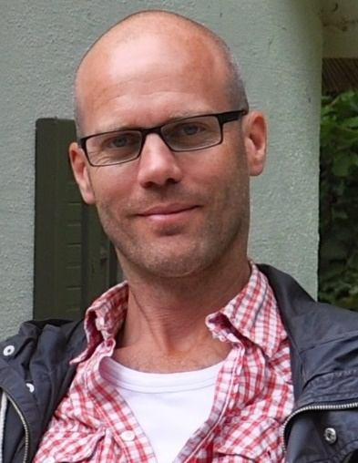
Biography

Olle Wirenhed (b. 1971) is a creative producer based in Gothenburg. Driven by the desire to find new talent and great stories Olle has worked in various positions within film production since 1997, gradually developing an ambition to create production frameworks that leave room for passion as the driving force. Olle is also the Swedish co-producer of the feature film Paradise Suite, selected for the Discovery programme in Toronto 2015.

Filmography (selected)

Feature Films

Tomelilla (script writer Niclas Ekström) Producer (in development) 2016
Cloudboy (dir Meikeminne Clinckspoor) Swedish co-producer (postp.) 2016
Devil´s Bride (dir Saara Cantell) Swedish co-producer 2016
The Paradise Suite (dir. Joost van Ginkel) Swedish co-producer 2016
Girls Lost (dir. Alexandra-Therese Keining) Producer 2016
Simon and the oaks (dir. Lisa Ohlin) Post Producer 2011
Ciao bella (dir. Mani Maserrat-Agah) Producer 2007
Offside (dir. Mårten Klingberg) Post Producer 2006
Slim Susie (dir. Ulf Malmros) 1stAD, Post Producer 2003
We can be Heroes! (dir. Ulf Malmros) Prod. manager, Post Producer 2002
Short Films

Fig (dir. Nicolas Kolovos) Producer 2015
Porsche (dir. Nicolas Kolovos) Producer 2013
I am gay (dir. Nicolas Kolovos) Producer 2008

TV-series

Fighters (dir. Alexandra-Therese Keining) Producer (in development) 2016
Bastian (dir. Roozbeh Behtaji) Producer 2012
Saltön 1 (dir. Carin Mannheimer) 1st assistant director 2004
Orka! Orka! (dir. Lisa Siwe, for SVT) 1st assistant director 2004
The Soloists (dir. Geir Hansteen Jörgensen) 1st assistant director 2003

Documentaries
Grown Ups (dir Shahriyar Latifzadeh) Producer 2014

Work shops 2014 -2016
Connected to the Sami Film Institute in Kautokeino as a scriptconsultant and producers menthor.

