HELLENIC REPUBLIC
UNIVERSITY OF PATRAS
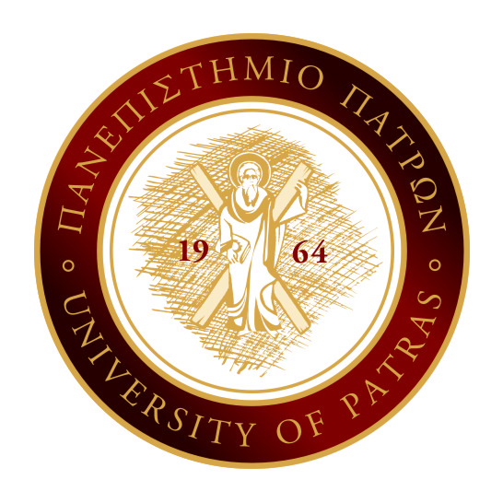
«Contemporary Approaches to the Performing Arts and Film (History, Theory, Identity Politics)»

SCHOOL OF HUMANITIES AND SOCIAL SCIENCES
DEPARTMENT OF THEATRE STUDIES

UNIVERSITY CAMPUS, 26500, RIO, PATRAS, GREECE
Email: theatric@upatras.gr http://www.theaterst.upatras.gr

DIPLOMA SUPPLEMENT
This Diploma Supplement model was developed by the European Commission, Council of Europe and UNESCO/CEPES. The purpose of the supplement is to provide sufficient independent data to improve the international 'transparency' and fair academic and professional recognition of qualifications (diplomas, degrees, certificates etc.). It is designed to provide a description of the nature, level, context, content and status of the studies that were pursued and successfully completed by the individual named on the original qualification to which this supplement is appended. It should be free from any value judgments, equivalence statements or suggestions about recognition. Information in all eight sections should be provided. Where information is not provided, an explanation should give the reason why.

- INFORMATION IDENTIFYING THE HOLDER OF THE QUALIFICATION
  - Family Name(s):
  - Given Name(s):
  - Student identification number or code:
  - Date of birth (day/month/year): Place, Country of Birth:

- INFORMATION IDENTIFYING THE QUALIFICATION
  - Name of the qualification (in original language): Postgraduate Diploma in “Contemporary Approaches to the Performing Arts and Film (History, Theory, Identity Politcs) ”
  - Main field(s) of study for the qualification: Theatre Science
  - Name and status of awarding institution/s (in original language): University of Patras, Public Higher Education Institute (HEI), Panepistimio Patron
  - Name and status of institution/s administering studies (in original language): -
  - Language(s) of instruction/examination: Greek

- INFORMATION ON THE LEVEL OF THE QUALIFICATION
  - Level of qualification: 2nd cycle (Postgraduate studies)
  - Official length of programme: Minimum length 4 academic semesters (2 academic years)
  - Access requirement(s): Admission to the master’s programme requires a degree of a related subject, excellent knowledge of at least one of the four main international languages (English, French, German or Italian), and successful examination in the Department’s entry written exam as well as an interview.

- INFORMATION ON THE CONTENT AND RESULTS GAINED
  - Mode of study: Full time attendance
  - Program requirements:
Terms, conditions (rules) of graduation and learning outcomes
In order to obtain the Postgraduate Diploma in “Contemporary Approaches to the Performing Arts and Film (History, Theory, Identity Politics)”, postgraduate students are required to attend and successfully complete eight (8) compulsory courses, as well as to successfully complete a thesis. The Programme Curriculum of the Postgraduate Diploma in “Contemporary Approaches to the Performing Arts and Film (History, Theory, Identity Politics)” means to train scientists capable to promote the knowledge, study and research in the field of Theatre and Film Studies and more specifically to use an interdisciplinary method which aims to combine the theoretical and methodological approaches to both the fields of the Performing Arts and Film with Gender and Feminist methodologies in the broader context of Cultural Studies.
Upon completion of their studies, in addition to the basic knowledge of their discipline and profession the graduates of the Postgraduate Diploma in “Contemporary Approaches to the Performing Arts and Film (History, Theory, Identity Politics)” will be able to develop research in the above mentioned specific subjects by writing scholarly articles, doctoral theses, and monographs; by editing academic texts; by compiling special bibliographies related to a specific subject; and by promoting relevant academic essays of any kind.

  - Program details (e.g. modules or units studied), and the individual grades/credits obtained): (if this information is available on an official transcript this should be used here)

CODE | COURSE | TYPE | Year/Semester | ECTS credits | Grade | Examination period
 | ………………………….. | C |  | 10 |  | e.g. June 2012
DIPLOMA GRADE |  |  |  |  | (GRADE)

For obtaining the postgraduate title the successful examination in eight (8) compulsory courses and/or in 120 credit units. In addition, every postgraduate student must successfully complete a Postgraduate Diploma Thesis.

4.4 Grading scheme and, if available, grade distribution guidance:
Student performance is evaluated as follows:
8.50 -10.00 | EXCELLENT
6.50 -8.49 | VERY GOOD
5.00-6.49 | GOOD

The above grading scheme corresponds exclusively to the grades and description indicated in the awarded postgraduate degree.

4.5 Overall classification of the qualification (in original language): 7.25 (VERY GOOD)

- INFORMATION ON THE FUNCTION OF THE QUALIFICATION
  - Access to further study: Doctoral Studies (Ph.D.)
  - Professional status (if applicable) : -
(Relevant information is reported)

- ADDITIONAL INFORMATION
  - Additional information:
(Other information relevant with the training of the title holder (e.g. further information for voluntary courses, exemptions, scholarships, Erasmus mobility etc).

  - Further information sources:
University of Patras: http://www.upatras.gr/el/post-grads
Department of Theatre Studies http://www.theaterst.upatras.gr
Ministry of Education and Religious Affairs: http://www.minedu.gov.gr/
European Union: http://www.ec.europa.eu

- CERTIFICATION OF THE SUPPLEMENT
  - Date:
  - Signature and full name:

Head of the Department | Secretary/Deputy Secretary

Capacity:

Official stamp

- INFORMATION ON THE NATIONAL HIGHER EDUCATION SYSTEM
https://eacea.ec.europa.eu/national-policies/eurydice/content/greece_en

